+
  project 3: Private doctor MANAGEMENT SYSTEM GROUP 10  TERM 2: INDIVIDUAL ASSIGNMENT | Name: Thabiso  Surname: Matsaba  Student Number: 220296006  Lecturer: Karin Swart  Due: 23 May 2022  Project 3

TABLE OF CONTENTS
Page

TABLE OF CONTENTS……............................................................................ ii
SECTION 1
Introduction....................................................................................................... 1
Kotlin belonging programming paradigms......................................................... 1
SECTION 2
Kotlin comparison on advantages, strengths, pitfalls with other programming languages in similar programming paradigms..................................................... 2
SECTION 3
How instructions written in Kotlin is executed by the computer.……………........................................................................................... 3
SECTION 4
The best use case(s) Kotlin.................................................................................. 4
SECTION 5
Bibliography……………………………………………………………………………. 5

- Project 3 Group 10 Private Doctor Application
Throughout the year, my group members and I are developing a private doctor application for android devices.
- Entity Relational Diagram(ERD)
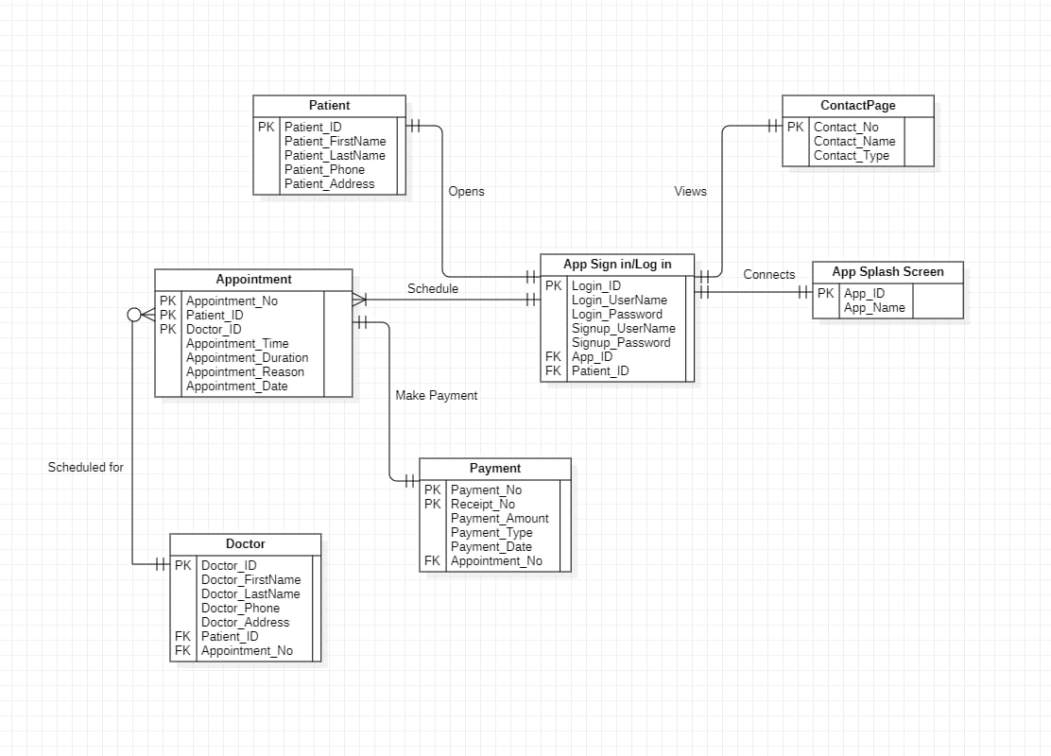
In our application, I have been tasked to code the Payment Entity Table. The payment table will address the appointment table in the ERD. When the user is done booking an appointment, the user will be redirected to the payment interface to pay for the appointment. The user will have a payment number, receipt number, payment amount, payment type(card, cash, zapper) and the payment date.
- Table name: Payment
Attributes: int Payment_No(PK)
int Reciept_No(PK)
int Payment_Amount
String Payment_Type
Date Payment_Date
int Appointment_No(FK)
- User Interface Design for Payment Entity

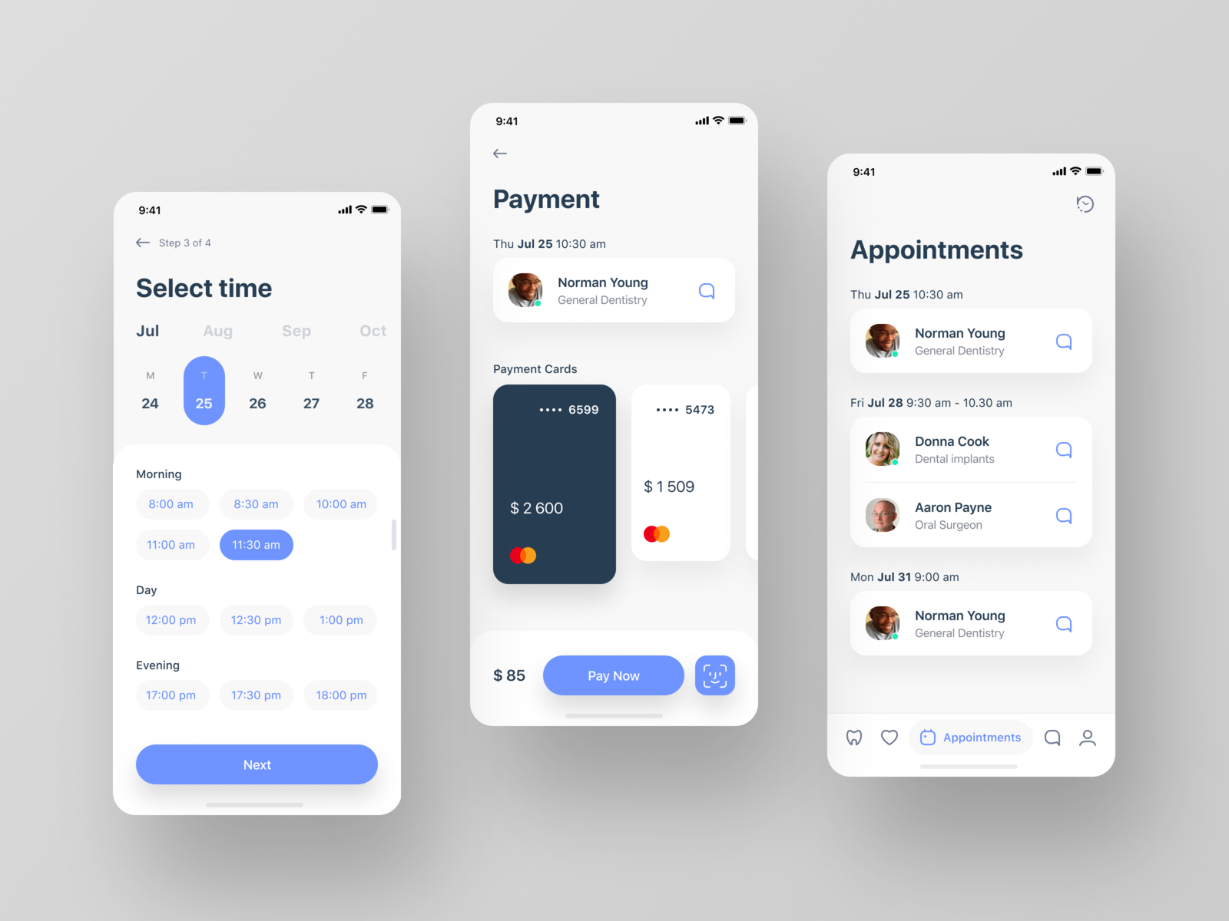
- Business Rules
- Each Patient must create one User Account. Each User Account must be created by one patient.
- Each Patient can Schedule one Appointment with one Doctor. An appointment gets scheduled by one Patient with one Doctor.
- Each Doctor can have many appointments. Each Appointment can have only one Doctor.
- Each Patient can view one Contact Page. Each contact page gets viewed by one Patient.
- Each Patient makes one payment for. Each payment is received by one Patient.
- Each payment gets issued one receipt. Each receipt is issued from one payment.

- Reflection
Issues encountered and how I addressed them:
The main issue I encountered was testing the functionally of payments to make sure everything works as intended. To test my payment interface, I had to assure a purchase flow proceeds smoothly and provides positive user experience within the application, plus implement logic that covers all possible subscription-related scenarios. And lastly validate those transactions will behave properly once the app is released.
Skills acquired and lessons learned:
I used a lot of relevant and useful technologies while coding my part of the application. I was not familiar with the Android Studio Integrated Development Environment (IDE), I watched a lot of YouTube tutorials to teach myself how to use it. I also learnt a lot about user experience best practices and to code using business logic and rules.
- GitHub
We have created a GitHub repository, which we use to collaborate and share code among all team members. The link for my repository: https://github.com/220296006/Project3-Group10.git

